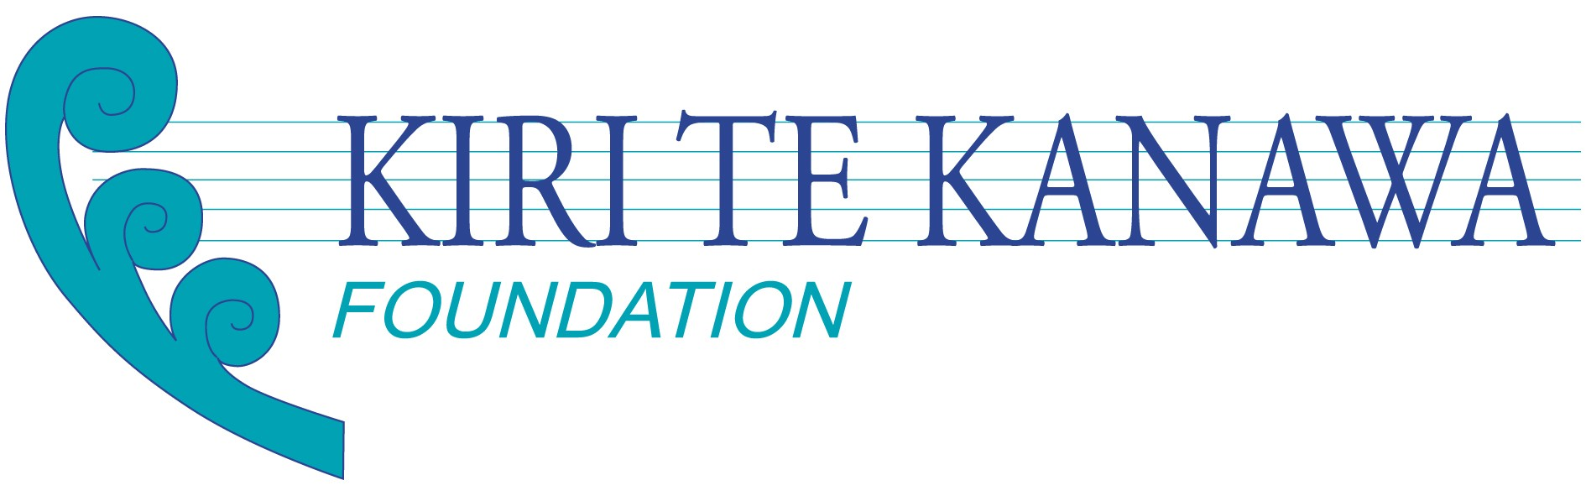
‘ARIA’

The newsletter of the Kiri Te Kanawa Foundation

Issue No 2/2004

Gala Concert DVD/CD

It’s on the way! EMI has announced that the CD and DVD of the spectacular Kiri & Friends Gala Concert will be released in New Zealand on November 7. The launch includes television and press advertising campaigns. EMI is excited about the potential sales for both of these beautiful reminders of the concert. All proceeds from sales will go to the Foundation.

Initially EMI will release the DVD and CD only in New Zealand. In a few months they will be released worldwide. In New Zealand they will be available from your favourite record store. Overseas Friends of the Foundation will have to wait for the international release or they can be purchased from the Marbeck Record Shop's website – www.marbecks.co.nz – phone 0800 11 33 44 (within New Zealand) and 64 9 379 0444 (from overseas). A word of warning for overseas Friends in North America and SE Asia – EMI advise us that you will not be able to view the New Zealand PAL DVD unless you have multi-standard DVD players and TVs – otherwise it’s best to wait for the DVD to be released in your territory.

Foundation makes first grant

The Kiri Te Kanawa Foundation, through its sister organisation The Friends of the Kiri Te Kanawa Foundation based in London, launched a significant initiative recently in providing financial support for NZ soprano Ana James. Ana is based in London pursuing her career in opera. The support was in the form of funds required for coaching and singing lessons and travel to a special coaching course in Pisa.



Foundation launched in London
An exclusive recital and dinner at Marlborough House marked the UK launch of the Kiri Te Kanawa Foundation and helped celebrate Dame Kiri’s 60th birthday as well. One hundred invited guests thoroughly enjoyed the evening, hosted by the Rt Hon Don McKinnon, Secretary General of the Commonwealth
Marlborough House is the home of the Commonwealth headquarters in London and provided a sumptuous setting for the evening. The lyricist and composer Charles Hart introduced the recital part of the evening and, in the presence of HRH The Princess Royal and HRH Princess Alexandra, Dame Kiri performed a short recital accompanied by Julian Reynolds and with special guest artist Jonathan Lemalu. Video screens then relayed the six messages of support recorded by absent friends of the Foundation (Placido Domingo, Sir Jackie Stewart, Dame Joan Sutherland, Neil Finn, Sir Edmund Hillary and HRH The Prince of Wales) which proved such a highlight of the Auckland Gala Concert.
The evening ended with an auction of three special items, which raised nearly £20,000.The event as a whole raised over £80,000.
Foundation office established

The Foundation office has been established at 349 Remuera Road, Remuera in Auckland. With the support of the Lion Foundation, a part-time Foundation manager has been appointed to handle enquiries and administer the development of the Foundation. Contact details are as follows:

Administrator: Paul Gleeson
Postal address: PO Box 28656, Remuera, Auckland
Phone: (64) (9) 5221310
Mobile: (64) (21) 944534
Fax: (64) (9) 5226856
E-mail: foundation@kiritekanawa.org
Website: www.kiritekanawa.org



Principles and funding process

The Foundation trustees recently confirmed the policy and procedures for reviewing grants. These included:
- The Foundation aims to assist outstanding New Zealand musicians and singers to develop international careers at the highest level.
- The Foundation believes that the recipe for career success in the performing arts is 20% inspiration and 80% perspiration. The Foundation will not look just for talent (though that will be a first base) but in addition has determined that young artists considered worthy of support will also have outstanding focus, drive and initiative.
- The Foundation plans to offer two broad types of support:
Mentoring – advice, master classes, influential introductions and other means of encouragement.
Funding for specific and agreed use, as negotiated with each recipient.
- The Foundation’s ongoing support of any individual will be driven by results.
- The Foundation seeks to add new value, not to duplicate or replace the existing work that is being done in this area by a range of individuals and institutions, including particularly the Dame Malvina Major Foundation, with whom the Foundation has a complementary relationship.
- The Foundation is not planning to run competitions or hold a series of open auditions to identify suitable recipients. Unsolicited applications from individuals will not be accepted. Instead the Foundation hopes that candidates suitable for consideration will be identified and recommended by practitioners, particularly teachers of music and singing, who are uniquely qualified to act as informal ‘talent scouts’. With this in mind Dame Kiri recently wrote a personal letter to 37 singing teachers in NZ explaining how the Foundation intended to operate and seeking their co-operation – the immediate response from this mailing has been very positive.

Your Help is Welcome

As you can see, the Kiri Te Kanawa Foundation is already beginning to make a difference for talented young New Zealand singers and musicians. Dame Kiri is delighted to see her dream of such support becoming a reality. The Foundation can only continue such work with your support, and all donations are welcome. If you should know of anybody else who is interested in becoming a Friend of the Foundation, please encourage them to contact us directly, and we will ensure they registered as a Friend. They will receive future newsletters and special offers – all we need is an email or postal address.

Finally a vote of thanks

We want to thank all those who attended the Gala Concert earlier this year which raised over $230,000 towards the Foundation Trust Fund.

We also want to thank the professional organisations and sponsors who are supporting the Foundation:

UBS
Rolex
ASB Bank
Porter Novelli (public relations services)
Morrison Kent (legal services)
The Lion Foundation
Paul Harrop & Company (accounting services)
EMI Music (New Zealand)



